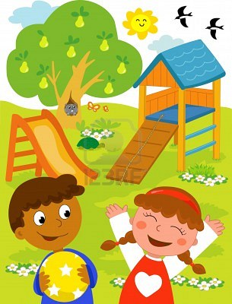C:\Users\welll002\AppData\Local\Microsoft\Windows\Temporary Internet Files\Content.IE5\Z1YRQR21\blockpage[1].gif

**THE 7 MOST IMPORTANT THINGS TO DO TOGETHER TO HELP YOUR CHILD LEARN AND DEVELOP**

