Reading in Reception
at
Forest Lodge Academy

- Partnership with parents is one of the most important factors in your child’s success.
- All children should now have a reading book
- It’s OK to keep the same book for a few days, but we are happy to change your child's reading book everyday
- We listen to your child read at least once a week in school
Introducing a picture book
- Picture books before reading books
- Learn how stories are structured-beginning, middle and end
- Gives children confidence to read
- Develop children’s comprehension skills
- Understand where the title is
- Look at pages from left to right
Early reading behaviour
- Look at picture
- Look at initial sound and guess
- Sound out the word (blend)
- Does it look like another word?
- Does it look and sound right?
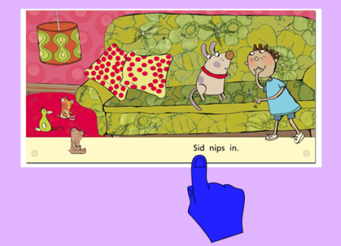
Applying Phonics
- Use the correct Phonics sounds
- Point to initial sounds
- Help children to blend the sounds
c-a-t
The Purpose of Phase 2
- To teach at least 19 letters
- To move children from oral blending and segmenting to blending and segmenting with letters.
- To read and spell some VC and CVC words (at & can)
- To read tricky/sight words
Letter Progression
Set 1: s, a, t, p
Set 2: i, n, m, d
Set 3: g, o, c, k
Set 4: ck, e, u, r
Set 5: h, b, f, ff, l,ll, ss
Sight words
- Phase 2 tricky words include: and, I, this, saw, mum, the, dad, a, on, no, to, go
- Children learn to read these by word recognition not by sounding out.

